A database is an electronically stored, systematic collection of data. It can contain any type of data, including words, numbers, images, videos, and files. You can use software called a database management system (DBMS) to store, retrieve, and edit data. In computer systems, the word *database* can also refer to any DBMS.

**Tree structured data (Hierarchical database) - couldn’t handle multiple parent-child relationships without significant data duplication.**

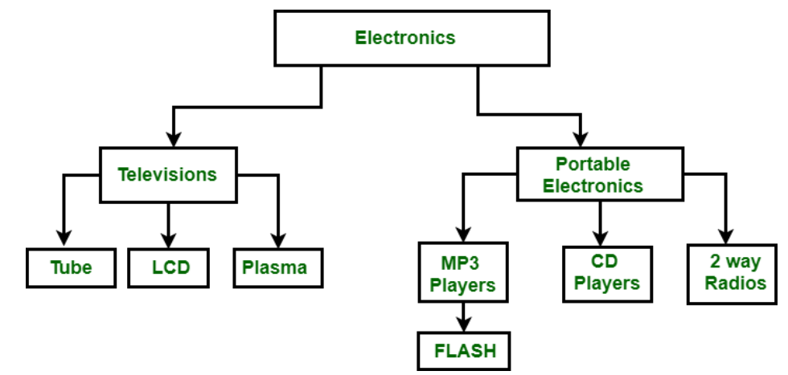

**Relational database (1970s) - organized records as several tables instead of linked lists.**

* **Data is stored in tables (relational model)**
* **Each data point in a relational database is written to a row with a unique ID (key) with other attributes corresponding to each column. Data is then retrieved via Structured Query Language (SQL), which is why relational databases are often called SQL databases.**

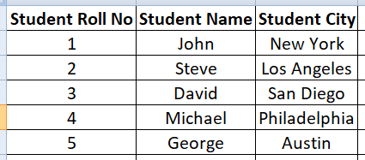

**Some of the most well-known RDBMSs include MySQL, PostgreSQL, MariaDB, Microsoft SQL Server, and Oracle Database.**

**AWS EC2 Instance with a Database application installed (like MySQL or MariaDB):**

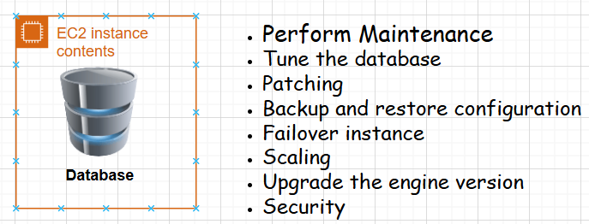

**Amazon Relational Database Service (Amazon RDS)** is a web service that makes it easier to set up, operate, and scale a relational database in the AWS Cloud. It provides cost-efficient, resizable capacity for an industry-standard relational database and manages common database administration tasks.

**AWS RDS is a Managed Service:**

* Manages backups and restore (automated with option of manual backups as well)
* Software patching
* Automatic failure detection and recovery
* High Availability with a synchronous secondary DB Instance to fail over (Multi AZ)
* Read replicas to support increased database read requests
* Enhanced security with Security Groups, IAM, and VPC

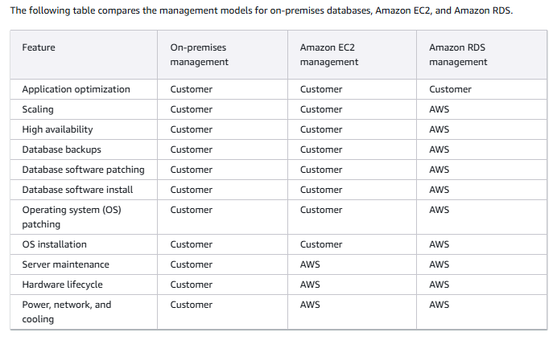

**Aurora vs RDS:**

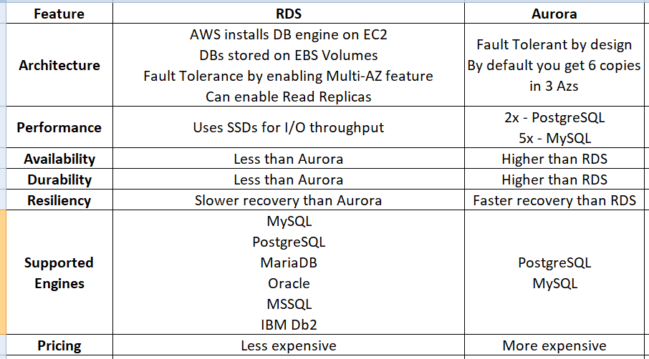

**AWS RDS DB Instances: An instance may consist of one or more user-created databases.**

**To install mariadb client on Amazon Linux 2:**

*sudo yum install mariadb -y*

**To login to an RDS instance with mysql:**

*mysql -h <RDS-endpoint> -u <RDS-Instance-Master-User> -p #This will prompt for password, enter the password for master user*

*show databases; #mysql command to list databases*

*use <database-name>;*

*show tables; #mysql command to show tables inside a database*